Mastering embedded systems Online Diploma

[www.learn-in-depth.com](http://www.learn-in-depth.com)

First Term (Final Project 1)

Eng. Mostafa Ahmed ElFallal

My Profile :

[mostafaelfallal90@gmail.com (learn-in-depth.com)](https://www.learn-in-depth.com/online-diploma/mostafaelfallal90%40gmail.com)

## Assumptions :

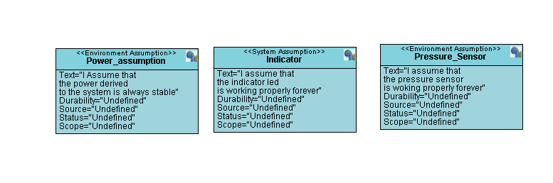

## Methodology :

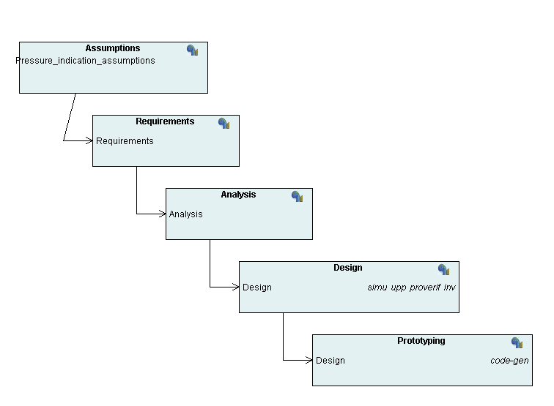

## Requirements :

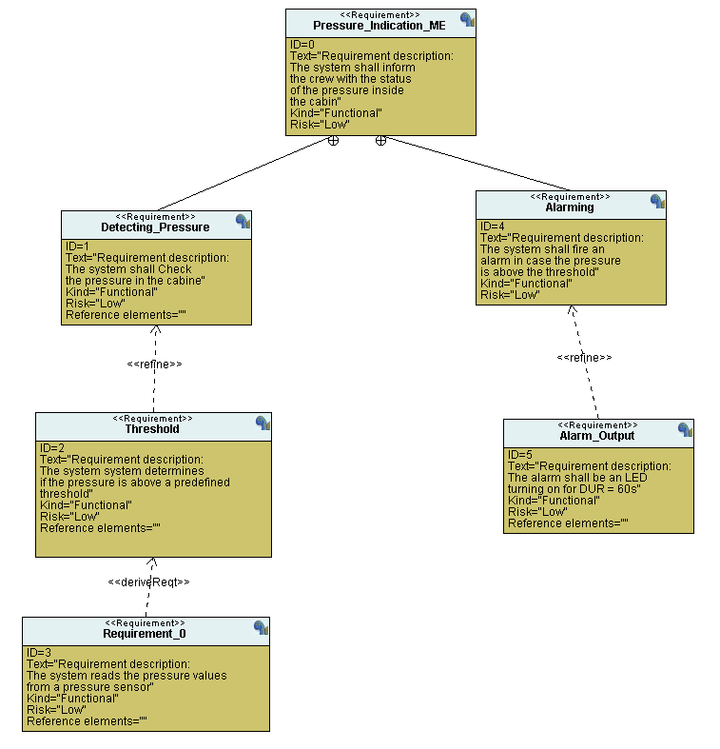

## System Analysis :

### Use Case diagram :

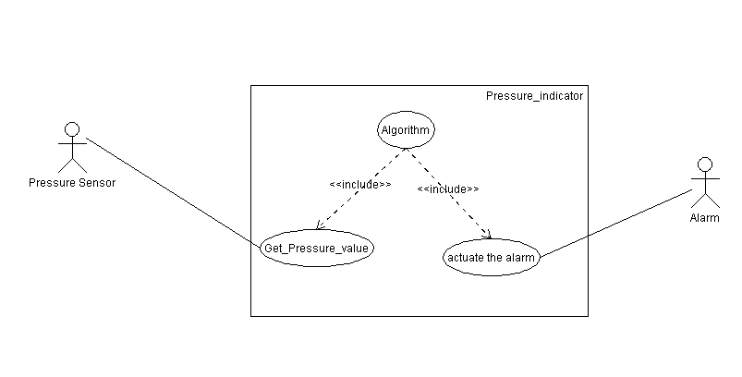

### Activity diagram :

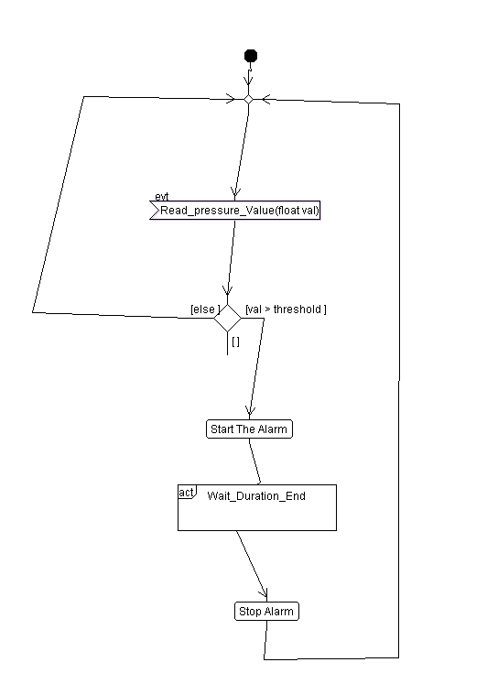

### Sequence diagram :

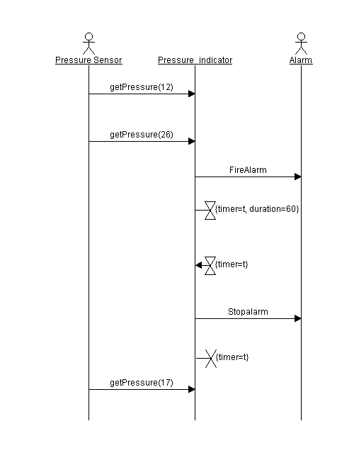

## System design :

### Block diagram :

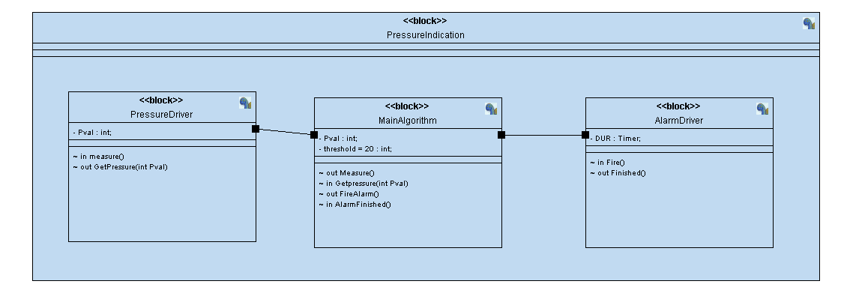

### Main Algorithm :

### 

### Alarm Driver :

### 

### Pressure Driver :

### 

### Using Makefile for building project

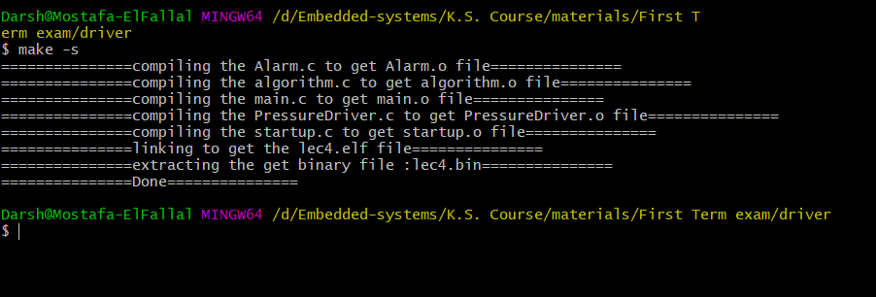

### Proteus :

At 30 bars as input > 20: 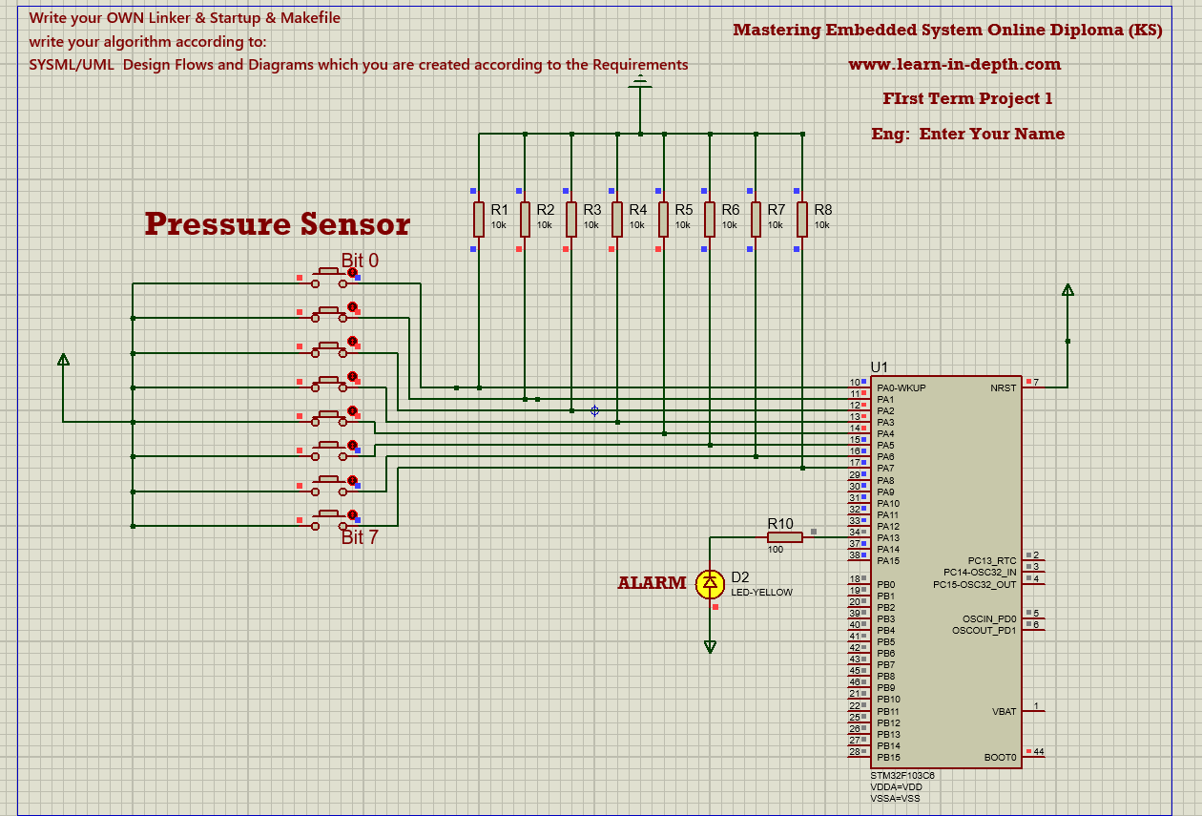

At 14 bars as input < 20 : 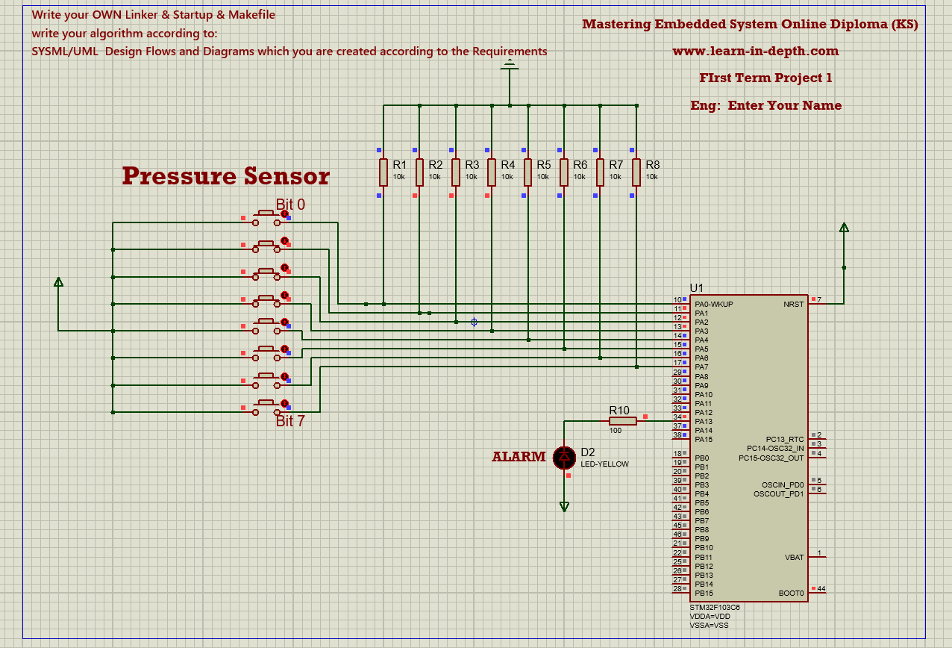

At exact 20 bars (still not greater than 20 ) :

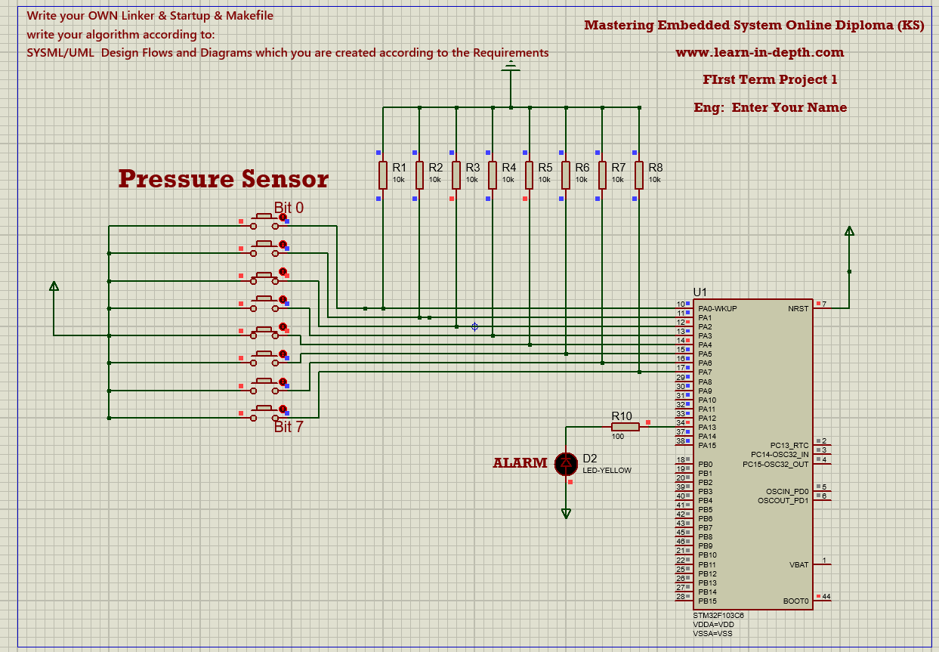

For full video for using the system :

<https://drive.google.com/file/d/1QLfYc-awMDE0p9snuvuzCfJJZ2pbeXsY/view?usp=sharing>